Murrumbeena Primary School Policy

Academic Honesty Policy

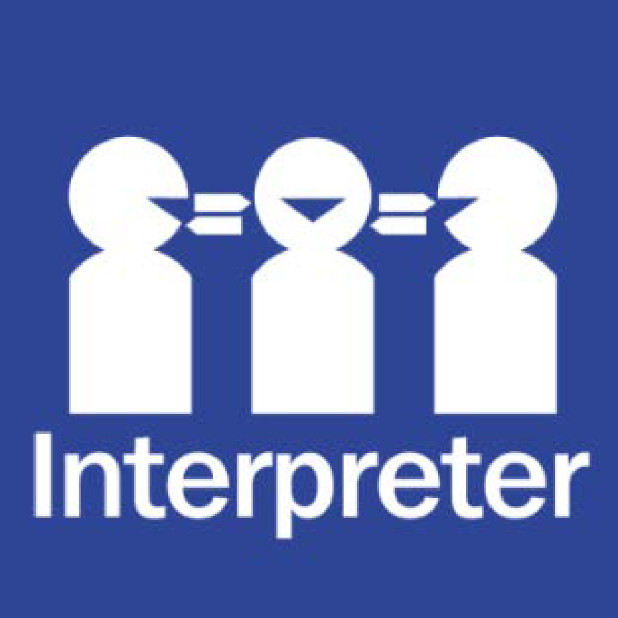
Help for non-English speakers
If you need help to understand the information in this policy please contact the Principal or Assistant Principal on 9568 1300.

RATIONAL/PURPOSE
Understanding and implementing academic honesty is an essential aspect of learning and teaching. The school community (leadership, teachers, students and parents) should act with integrity and honesty by valuing, respecting and acknowledging sources of information when presenting and publishing their ideas.

Academic honesty supports the development of school values (respect, responsibility, relationships and resilience) and is required to support the implementation of an inquiry learning approach. A broad range of primary and secondary resources are utilised through transdisciplinary learning in order to support the development of dispositions (learner profile attributes), capabilities and skills (approaches to learning) required for lifelong learning and international mindedness.

This policy fosters a whole-school culture of honesty, trust and respect for intellectual property and supports students to become principled learners who act ethically and responsibly.

AIMS
The aims of the policy are to:
- Raise the awareness and expectations of academic honesty within the school community.
- Provide guidelines on how to be academically honest in learning and teaching.
- Identify ways to support students to develop skills and understandings necessary to act with academic honesty.
- Promote the development of the IB Learner Profile attributes and Approaches to Learning (ATL) to strengthen students’ understanding and practice of academic honesty.
- Ensure alignment with the IB’s Academic Integrity Policy (2022) and support the implementation of ethical practices in assessment and inquiry.

SCOPE
This policy applies to all members of the Murrumbeena Primary School community. It is an expectation that staff, students and parents adhere to the Academic Honesty Policy at all times.
It applies across all subject areas and units of inquiry within the IB Primary Years Program (PYP), including the use of digital and AI technologies.
DEFINITIONS
Academic honesty means doing your own work and acknowledging sources used to gather information and ideas.
Academic dishonesty means presenting the work of others as your own.
Academic integrity means acting ethically and honestly to produce authentic work.
Paraphrasing means writing new knowledge from information sources in your own words.
Reference means recording the source of information used.
Quote means recording information directly from a text.
Quotation marks means punctuation used to identify quotes (‘xxx’).
Citation means identifying the source of specific information in your work.
Plagiarism means presenting the work or information of others as your own.
Authentic means a unique idea or creation of a person or group.
Generative Artificial Intelligence (AI) - Online tools which generate new content such as text, images, audio and video that resembles what humans can produce.

GUIDELINES/ROLES AND RESPONSIBILITIES
The school is responsible for:
- Informing the school community of their Academic Honesty Policy.
- Supporting the implementation of their Academic Honesty Policy.
- Providing necessary resources for the school community to carry out their roles and responsibilities with academic honesty.
- Embedding the policy across the Programme of Inquiry, school curriculum, digital learning policy, and student reflection tools.
- Providing professional development and reflection opportunities for staff on academic honesty and ethical practices.
- To provide families with updated student digital policies to sign and return to school.

Teachers are responsible for:
- Implementing the digital licences at school and sending home information forms to the parents.
- Creating digital licence essential agreement alongside students.
- Monitoring the correct use of websites through Apple Classroom and LAN Schools.
- Respecting copyrighted resources, both print and online, by not using them without seeking the correct permission.
- Adhering to the Statutory Education Licence, https://www.copyright.com.au/licences-permission/educational-licences/, 21/06/2024,
- Using AI in line with Australian Framework for Generative Artificial Intelligence in Schools, Australian Government Department of Education.
https://www.education.gov.au/schooling/resources/australian-framework-generative-artificial-intelligence-ai-schools, 21/06/2024
- Modelling the use of academic honesty in their teaching.
- Monitoring the implementation of academic honesty in all learning and teaching including assessment.
- Identifying when breaches of academic honesty occur and supporting students to understand correct behaviours and learn appropriate skills required.
- Supporting all students to understand the school and societal expectations around academic honesty and what the possible consequences of academic dishonesty are.
- Teaching reading comprehension skills (e.g.summarising, identifying main idea, identifying key details, skimming and scanning, inferring) and note taking skills necessary for students to be able to paraphrase.
- Teaching age appropriate knowledge and skills to support the understanding and implementation of academic honesty across the school, specifically:
By the end of Year 2:
- Understanding the concept of writing what they have learnt in their own words.
- Showing or explaining their information sources.
By the end of Year 4:
- Beginning to understand the terminology including: academic honesty, reference, quote, quotation marks, paraphrasing.
- Understand how to reference a book (author, title, page number) and website (Website Title, URL, date).
- Use quotation marks to record text which has been directly copied.
By the end of Year 6:
- Understanding terminology including: academic honesty, reference, quote, quotation marks, paraphrasing, plagiarism and citation.
- Understand how to reference a book (author, title, publisher, year of publication, page number) and website (Website Title, URL, date).
- Understand how to use quotation marks to record text which has been directly copied.
- Use strategies for the citation of a source.
- Understand how to use AI tools responsibly, including acknowledging AI-generated contributions and seek teacher permission.
- Collaborating with the PYP Coordinator to ensure consistency with IB integrity principles.
- Supporting students to reflect on their learning and use of sources, promoting learner agency and ethical decision making.

Students are responsible for:
- Being principled by submitting work that is their own.
- Respecting copyrighted text and images and not using them without seeking the correct permission.
- Using age appropriate skills to comprehend and paraphrase from information sources.
- Using age appropriate skills to cite/reference work of others (refer to teacher section).
- Using digital AI tools ethically, with transparency and teacher guidance.
- Engaging in reflection to evaluate whether their work demonstrates academic integrity.
- Applying ATL skills such as research, thinking and communication in an ethical and responsible way.
- Seeking appropriate sources of information eg. library, reliable websites
- Adhering to the digital licence’s essential agreement - following the expectations.

Parents are responsible for:
- Understanding and supporting academic honesty.
- Discussing with their children the importance of academic honesty.
- Being transparent when they have supported their child/ren to complete learning tasks.
- Encouraging their children to submit work that is authentically their own.
- Supporting students to use reliable primary and secondary sources of information responsibly.
- Modelling ethical behaviour and working in partnership with the school to reinforce academic integrity expectations at home.
- Ensuring students adhere to the digital license agreement at home and that they are following the expectations.

BREACHES OF ACADEMIC HONESTY
Breaches of academic honesty will be addressed as learning opportunities, especially in the early years of schooling. The response will be developmental and supportive.

In cases of suspected or confirmed dishonesty:
- Teachers will engage the student in a reflective discussion.
- The relevant academic honesty skills will be explicitly retaught.
- A learning opportunity will be provided to correct and resubmit the task.
- Parents and leadership may be informed depending on the nature and frequency of the incident.

EVALUATION
Evaluation of the policy occurs formally every four years and is informed by school community feedback.
This policy will be reviewed annually by the PYP leadership team, with adjustments made in a timely manner to stay up to date with latest technological developments.

REFERENCES
IB Publications

Academic Integrity, International Baccalaureate Organisation, https://resources.ibo.org/ib/topic/Academic-honesty/works/edu_11162-58121?root=1.6.2.2.7&lang=en&odd=ibo.odd&view=div , 21/06/2024

Programme Standards and Practices (Standard C3), International Baccalaureate Organisation, Published January 2014, Last update: 28/04/2022https://resources.ibo.org/ib/psp/Standards-and-Practices/works/edu_11162-51685?lang=en, 21/06/2024

POLICY REVIEW AND APPROVAL
Policy last reviewed | October 2025
Approved by | Principal, PYP Coordinator, Education Sub Committee
Next scheduled review date | October 2029

