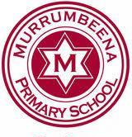
Murrumbeena Primary School Policy

Assessment and Reporting Policy

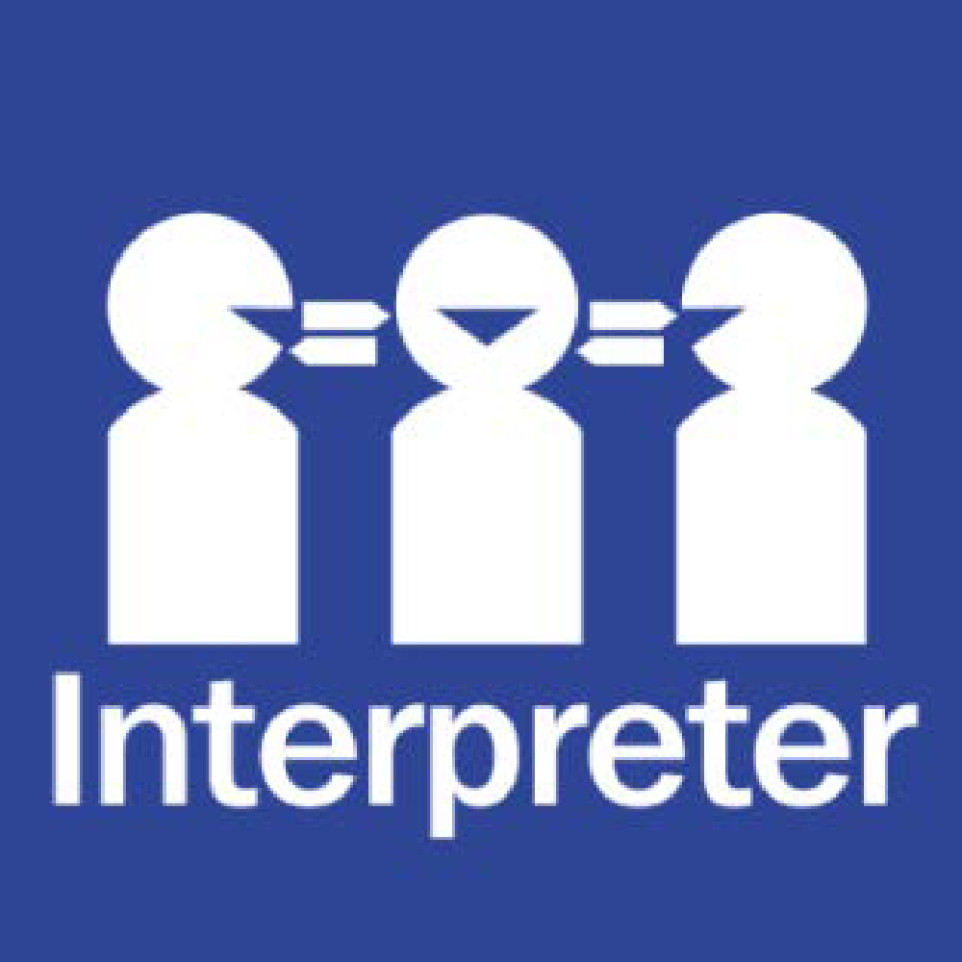
Help for non-English speakers
If you need help to understand the information in this policy please contact Murrumbeena Primary School on 9568 1300.

PURPOSE
At Murrumbeena Primary School, we believe that assessment is an integral part of the learning continuum. It is vital that effective and comprehensive monitoring and feedback take place in order that all students experience continuous learning and growth, assessment fostering development rather than merely measuring it.
Thorough assessment enables teachers to reflect on and modify their practice to suit students’ needs. It provides an overview of learning across the school and identifies and addresses areas in need of specific focus, ensuring the school’s assessment philosophy remains transparent and equitable.
AIMS
Assessment at Murrumbeena Primary School aims to:
- Highlight student progress through regular and ongoing feedback to inform next steps in learning.
- Provide students with varied opportunities to demonstrate knowledge, skills, and understanding in authentic and inclusive ways.
- Enable teachers to reflect on practice and track student growth over time.
- Empower students to reflect on their learning, supporting the development of self-management, agency, and metacognitive skills.
- Provide parents with clear and accessible information about their child’s progress, strengths, and future learning goals.
- Encourage goal-setting that is both challenging and achievable for students.
- Ensure assessment practices are holistic, inclusive, and support the development of learner agency.
Assessment in our school is:
- Differentiated – responsive to diverse learners’ needs and abilities.
- Continuous – embedded throughout the learning process.
- Reflective – encourages students and teachers to think about learning and identify areas for growth.
- Collaborative – involving students, teachers, and parents in understanding progress and next steps.
GUIDELINES
We use a balance of Assessment for Learning, as Learning, and of Learning, employing a variety of formal and informal tools. In this way, assessment is used to promote learning and not just measure progress.
A full list of assessment tasks across the school is detailed in the Murrumbeena Primary Assessment Schedule, which is reviewed and updated each term.
Assessment for Learning (Prior Assessment)
Teachers use frequent assessments to map student progress and guide teaching. This includes:
- Topic- or concept-focused pre-tests, prior assessments in units of inquiry, and teacher-generated tasks. Examples of these include genre-based writing tasks, topic-based maths tests, and thinking routines in units of inquiry.
- Standardised tests. Examples of these include Progressive Achievement Test (PAT), Early Years Literacy and Numeracy Interviews, and spelling tests.
Assessment as Learning (Formative Assessment)
Teachers use strategies that search for depth of understanding and promote metacognition. Students reflect on and monitor their progress to develop goals throughout the year. Tools include:
- Observations, anecdotal records, checklists, rubrics, comparison with worked examples.
- Work samples, self-assessment, peer assessment.
Assessment of Learning (Summative Assessment)
Judgements on achievement are based on evidence against the achievement standards of the Victorian Curriculum 2.0. Emphasis is placed on assessing both the process and product of inquiry. Tools include:
- PYP Summative Tasks, PYP Exhibition.
- Post-tests, student work samples, moderated learning tasks, exit tickets from lessons.
- Presentations/performances.
- External assessments: NAPLAN (Years 3 and 5).
These approaches ensure fair and valid assessment, supporting all students to demonstrate progress and success.
REPORTING
Student progress is reported to parents and the community through:
- Twice-yearly formal written reports, measuring progress against the Victorian Curriculum 2.0. Semesterly reports also communicate development of the Learner Profile and demonstration of the school values.
- Termly communication of student progress online through the Murrumbeena Primary Learning Continuum (aligned to the Victorian Curriculum 2.0 and Programme of Inquiry).
- Term 1 information evening and twice-yearly parent–teacher discussions.
- Ad hoc formal and informal interviews as requested.
- Distribution of NAPLAN results.
- ‘Unit Shares’ open classrooms at the end of each unit of inquiry.
INCLUSION AND POLICY COHERENCE
This policy works in harmony with the school’s other IB-mandated policies, fostering coherence, alignment, and integration of the Learner Profile attributes and international-mindedness across all practices. Teachers and leadership use the policy in planning, reflection, and decision-making, ensuring it is a living document embedded in the school’s culture.
EVALUATION
The policy is regularly reviewed to ensure it continues to meet the needs of the school and to sustain a culture of continuous learning.
POLICY REVIEW AND APPROVAL
Policy last reviewed | October 2025
Approved by | Principal
Next scheduled review date | October 2029

